Design Principles - Maintainability & Evolvability
# Source: AI Source: Provided by: [Data Path: Persons Table -> ID Column: 1, Name_En Column: Motasem Essam] -> From: [ChatGPT] on [1/23/2026]
Maintainability & Evolvability is the principle of designing software so it can be easily updated, extended, or modified over time without breaking existing functionality.
👉 Think of it like a well-organized house: you can renovate or add rooms without tearing down the whole structure.

🔑 Key Points
# Source: AI Source: Provided by: [Data Path: Persons Table -> ID Column: 1, Name_En Column: Motasem Essam] -> From: [ChatGPT] on [1/23/2026]
- Code should be readable, modular, and well-documented
- Supports refactoring and adding new features with minimal risk
- Encourages consistent coding standards and architecture principles
- Essential for long-lived systems and evolving requirements

❌ Bad Example
# Source: AI Source: Provided by: [Data Path: Persons Table -> ID Column: 1, Name_En Column: Motasem Essam] -> From: [ChatGPT] on [1/23/2026]
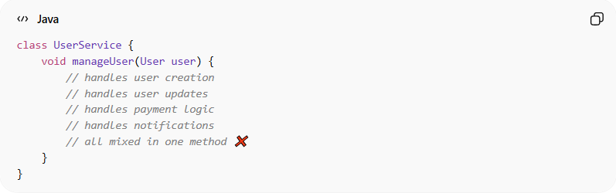
class UserService {
void manageUser(User user) {
// handles user creation
// handles user updates
// handles payment logic
// handles notifications
// all mixed in one method ❌
}
}
Problems:
- Single method does too much → hard to update
- Adding a new feature risks breaking existing logic
- Difficult for new developers to understand

✅ Good Example
# Source: AI Source: Provided by: [Data Path: Persons Table -> ID Column: 1, Name_En Column: Motasem Essam] -> From: [ChatGPT] on [1/23/2026]
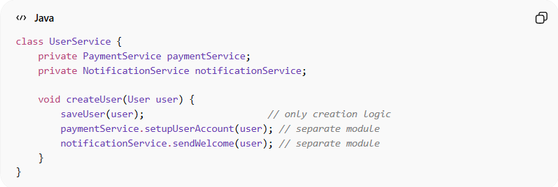
class UserService {
private PaymentService paymentService;
private NotificationService notificationService;

void createUser(User user) {
saveUser(user); // only creation logic
paymentService.setupUserAccount(user); // separate module
notificationService.sendWelcome(user); // separate module
}
}
Benefits:
- Each component is modular and understandable
- Easier to update, refactor, or extend
- Supports long-term system evolution
- Reduces technical debt

⚡ When to Apply
# Source: AI Source: Provided by: [Data Path: Persons Table -> ID Column: 1, Name_En Column: Motasem Essam] -> From: [ChatGPT] on [1/23/2026]
- Always in enterprise and long-lived applications
- Essential when requirements change frequently
- Works best with high cohesion, loose coupling, and testable design

